Võ Hoàng Hiệp ITCSIU22261

Task 1
Task 1.1: Project Setup (5 points)
Create a new Web Application project:

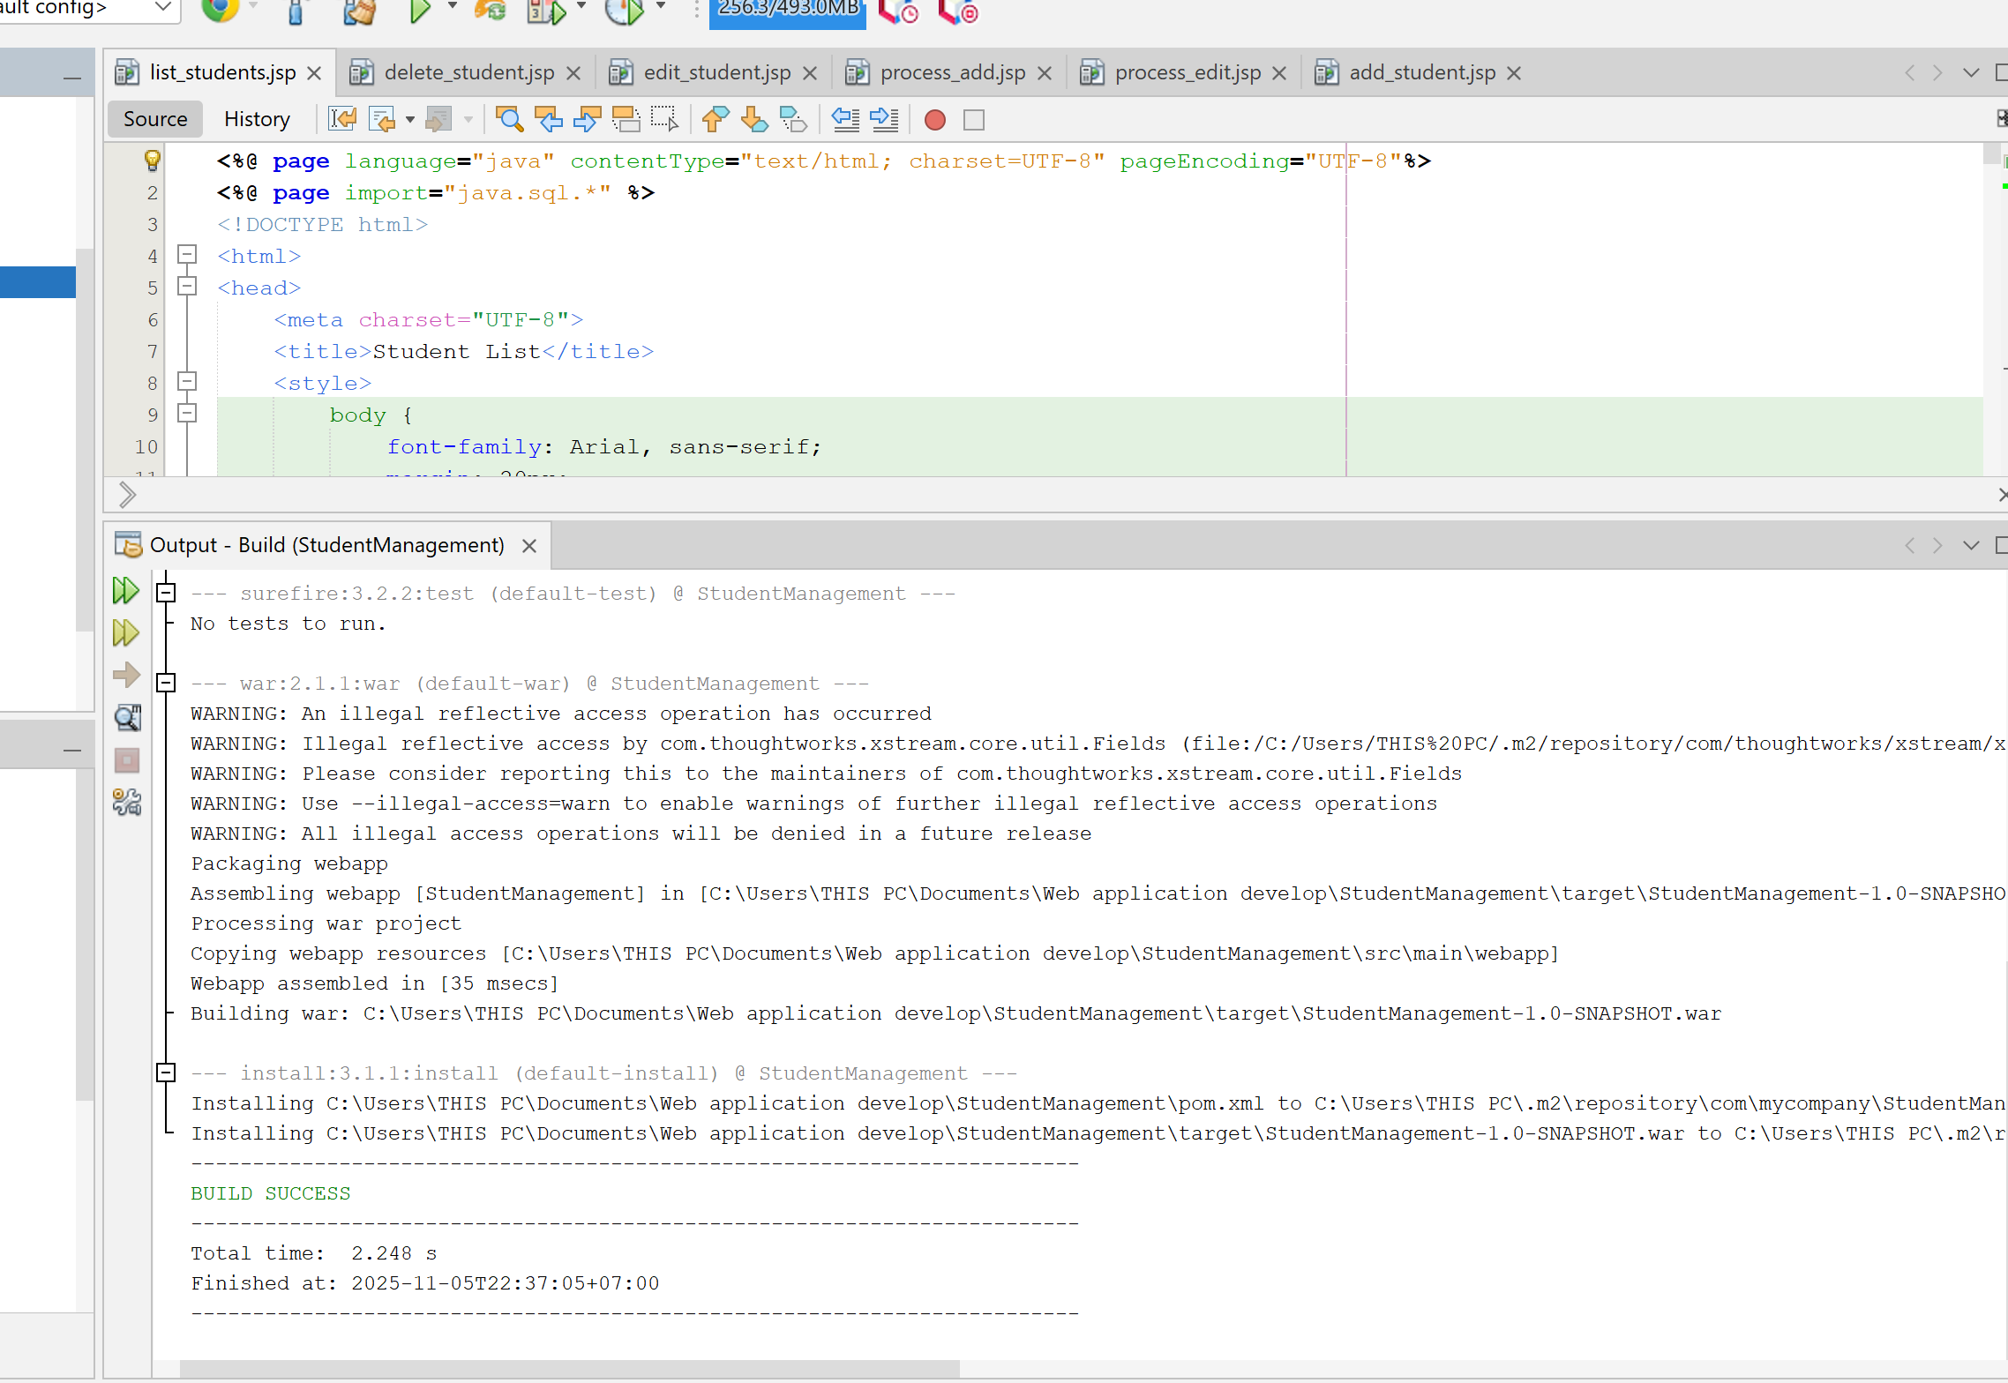
Task 1.2: Display Student List (10 points)
Create list_students.jsp that displays all students in a table.
Requirements:
- Connect to database using JDBC
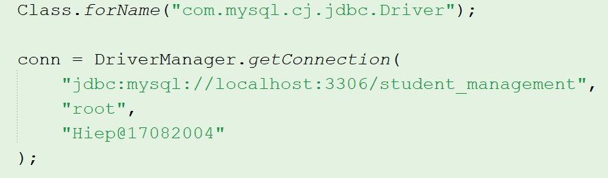
Class.forName(): get driver JDBC of MySQL
DriverManager.getConnection(): open to connect to database student_management on localhost.
- Query all students from students table
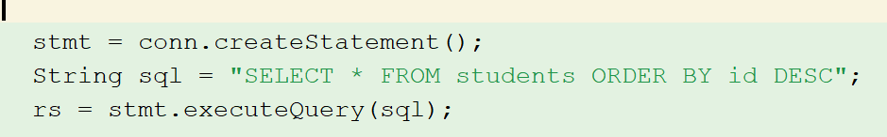
createSatement(): create statement to sent SQL
execcuteQuery(sql): execute query and return
- Display in HTML table with columns:
  - ID
  - Student Code
  - Full Name
  - Email
  - Major
  - Created At
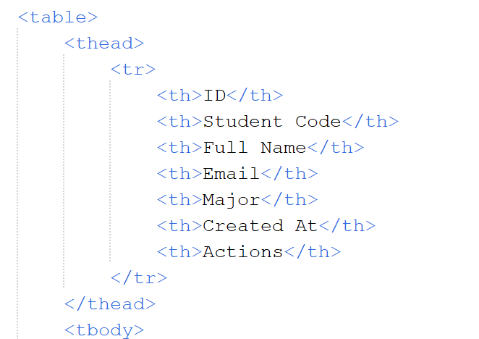
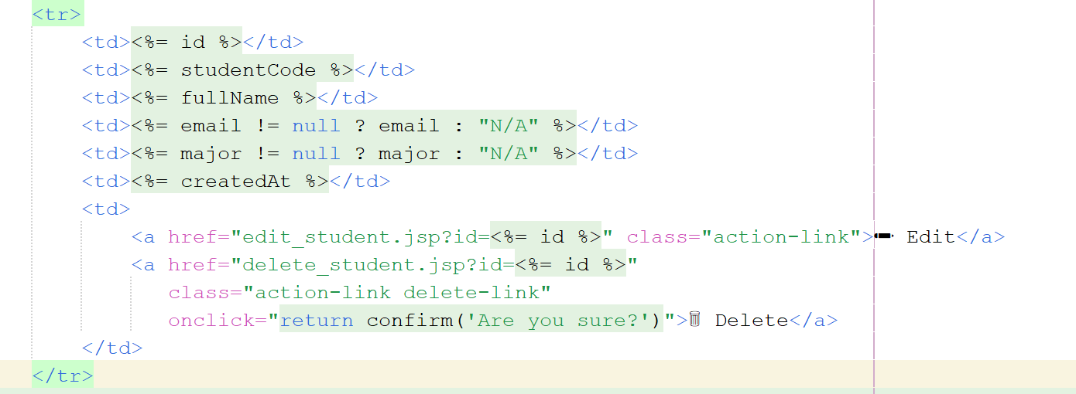
- Handle database errors gracefully
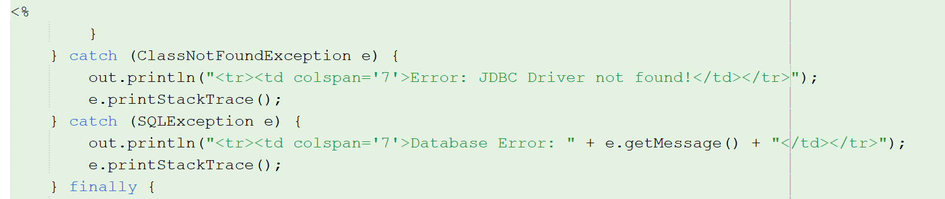
- Close all database resources properly
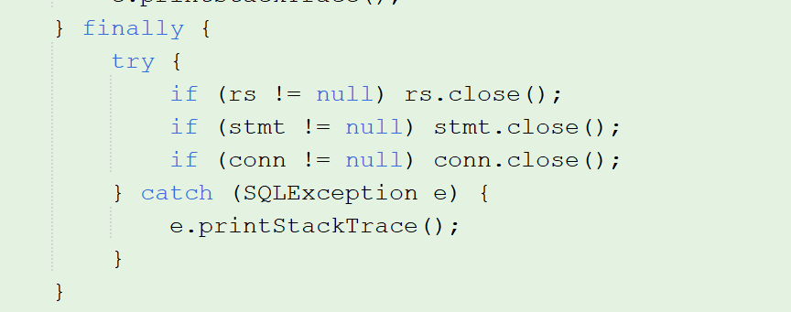

Testing:
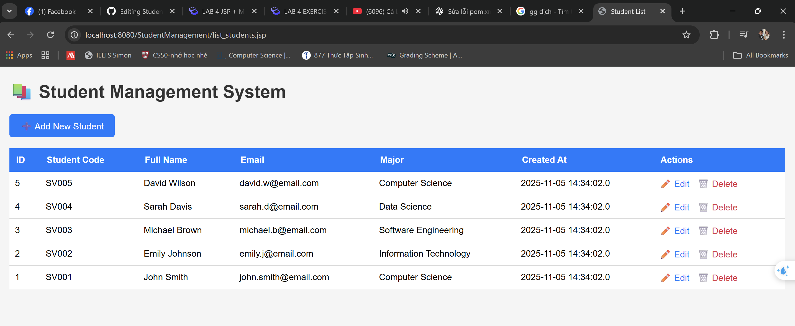

EXERCISE 2: CREATE OPERATION (15 points)
Task 2.1: Create Add Student Form (5 points)
Create add_student.jsp with a form to add new students.
Requirements:
- Form fields:
  - Student Code (text, required)
<div class="form-group">
<label for="student_code">Student Code <span class="required">*</span></label>
<input type="text" id="student_code" name="student_code"
placeholder="e.g., SV001" required
pattern="[A-Z]{2}[0-9]{3,}"
title="Format: 2 uppercase letters + 3+ digits">
</div>
  - Full Name (text, required)
<div class="form-group">
<label for="full_name">Full Name <span class="required">*</span></label>
<input type="text" id="full_name" name="full_name"
placeholder="Enter full name" required>
</div>
  - Email (email type, optional)
<div class="form-group">
<label for="email">Email</label>
<input type="email" id="email" name="email"
placeholder="student@email.com">
</div>
  - Major (text, optional)
<div class="form-group">
<label for="major">Major</label>
<input type="text" id="major" name="major"
placeholder="e.g., Computer Science">
</div>
- Submit button
<button type="submit" class="btn-submit">💾 Save Student</button>
- Cancel button (link back to list)
<a href="list_students.jsp" class="btn-cancel">Cancel</a>
- Use POST method
<form action="process_add.jsp" method="POST">
- Basic HTML5 validation (required attribute)
<% if (request.getParameter("error") != null) { %>
<div class="error">
<%= request.getParameter("error") %>
</div>
<% } %>

Task 2.2: Process Add Student (10 points)
Create process_add.jsp to handle form submission.
Requirements:
- Retrieve form parameters using request.getParameter()
String studentCode = request.getParameter("student_code");
String fullName = request.getParameter("full_name");
String email = request.getParameter("email");
String major = request.getParameter("major");
- Server-side validation:
  - Student code and full name are required
  - Display error if validation fails
if (studentCode == null || studentCode.trim().isEmpty() ||
fullName == null || fullName.trim().isEmpty()) {
response.sendRedirect("add_student.jsp?error=Required fields are missing");
return;
}
- Insert data using PreparedStatement
String sql = "INSERT INTO students (student_code, full_name, email, major) VALUES (?, ?, ?, ?)";
pstmt = conn.prepareStatement(sql);
pstmt.setString(1, studentCode);
pstmt.setString(2, fullName);
pstmt.setString(3, email);
pstmt.setString(4, major);
int rowsAffected = pstmt.executeUpdate();
- Handle duplicate student code error
if (rowsAffected > 0) {
response.sendRedirect("list_students.jsp?message=Student added successfully");
} else {
response.sendRedirect("add_student.jsp?error=Failed to add student");
}
- Redirect to list page on success with message
- Display error message on failure
catch (SQLException e) {
String errorMsg = e.getMessage();
if (errorMsg.contains("Duplicate entry")) {
response.sendRedirect("add_student.jsp?error=Student code already exists");
} else {
response.sendRedirect("add_student.jsp?error=Database error");
}
e.printStackTrace();
Test Cases:
Test | Input | Expected Result
Valid data | Code: SV006, Name: John Doe | Success, redirects to list
Empty required field | Code: (empty), Name: John | Error: "Required fields missing"
Duplicate code | Code: SV001 (existing) | Error: "Student code already exists"
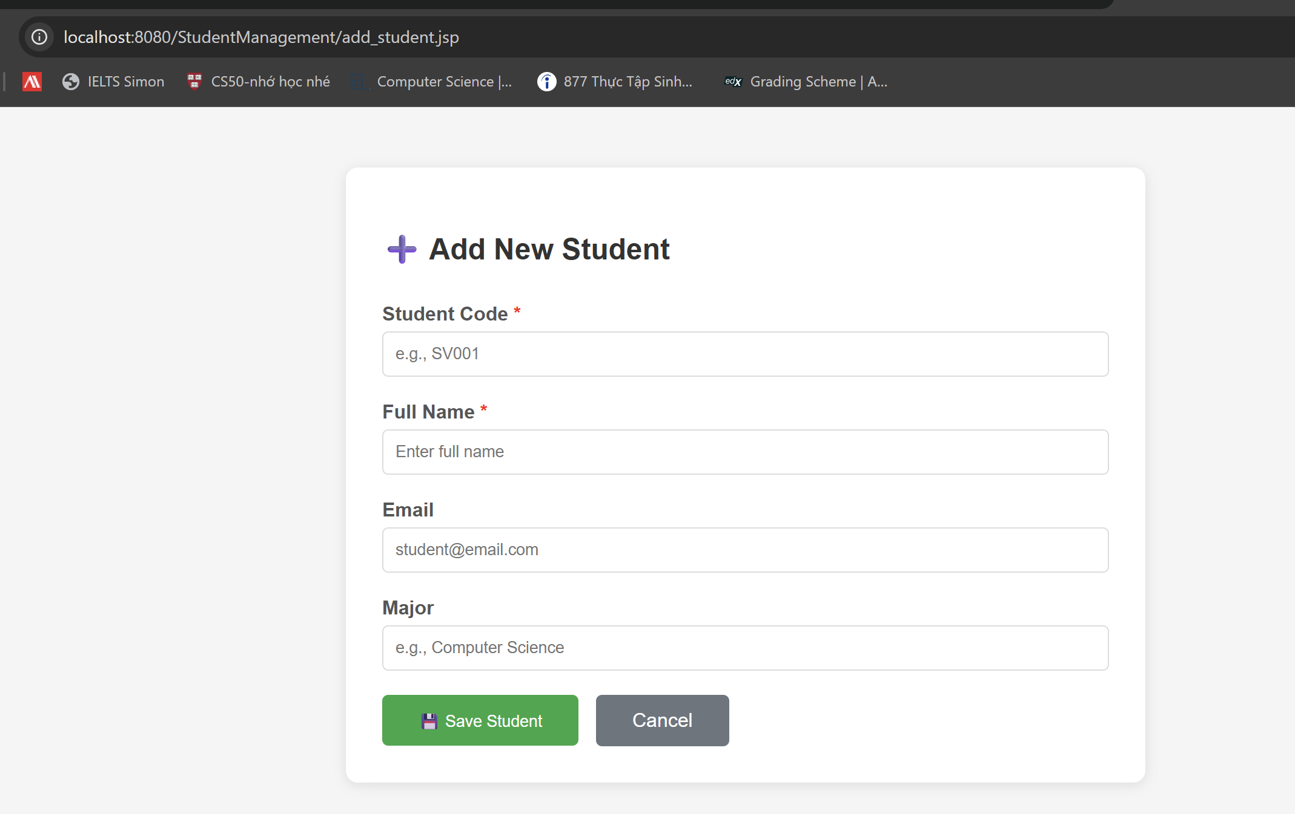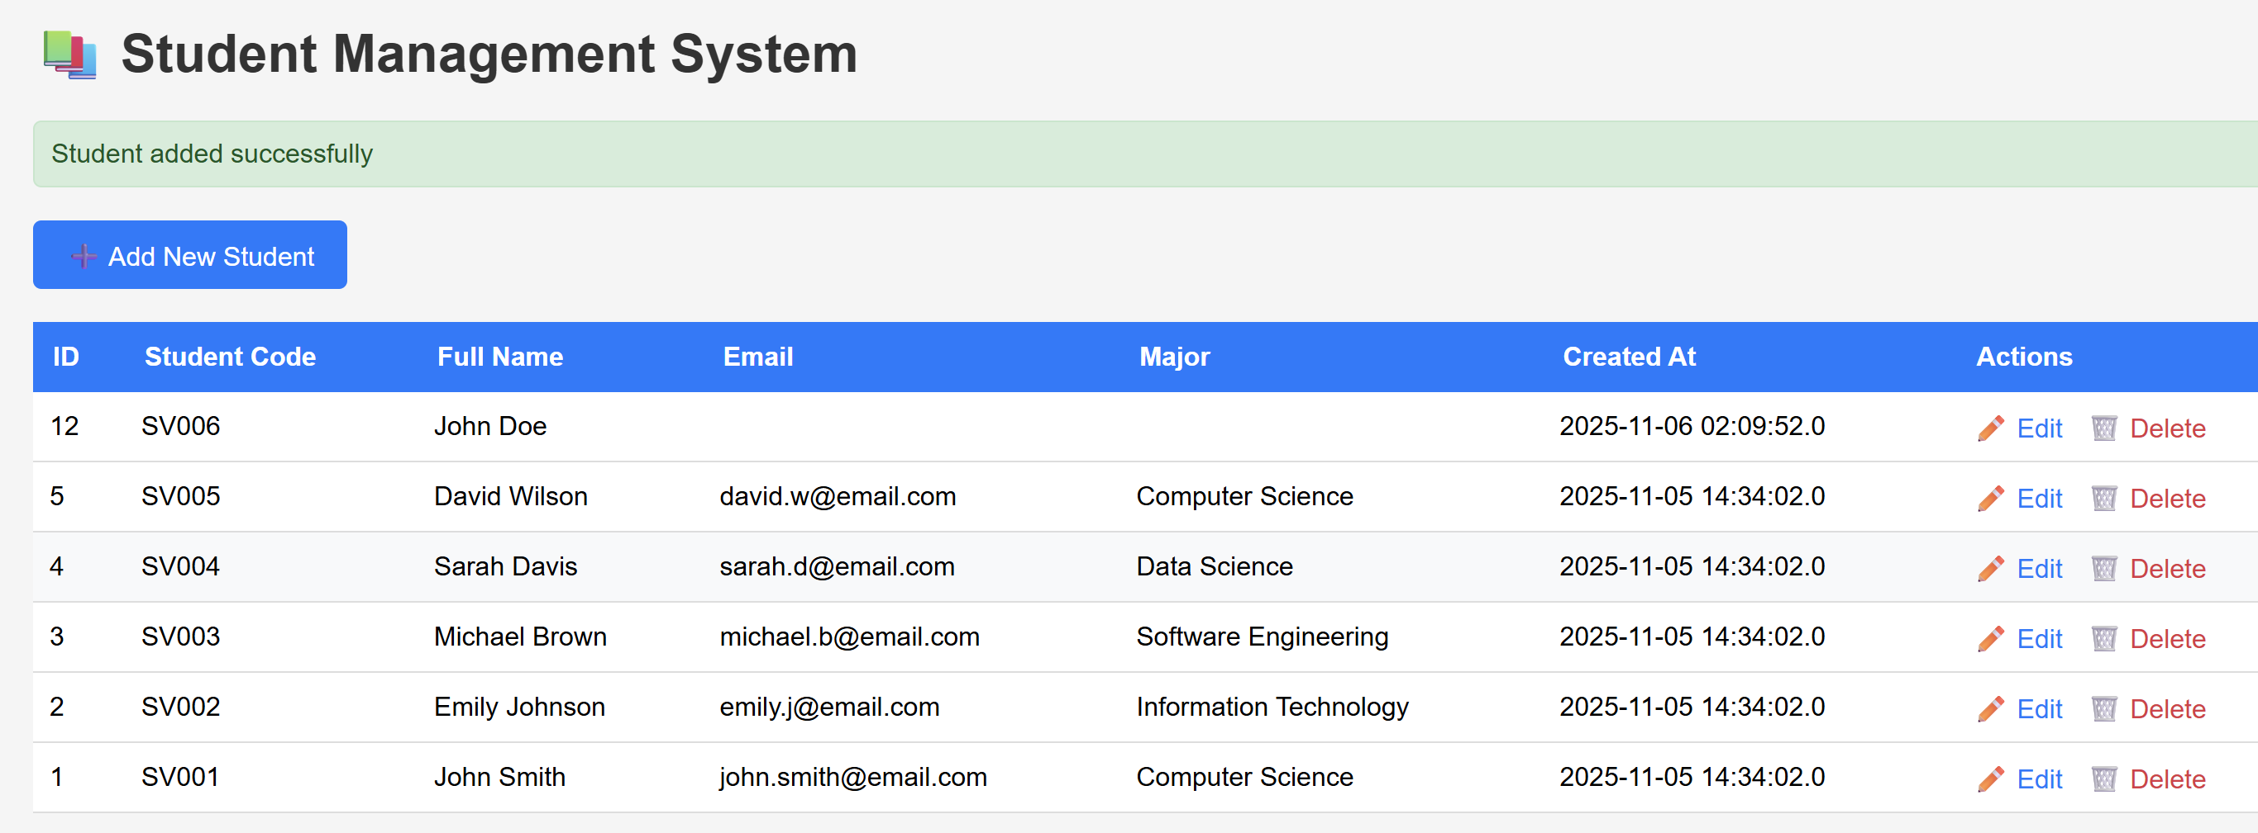
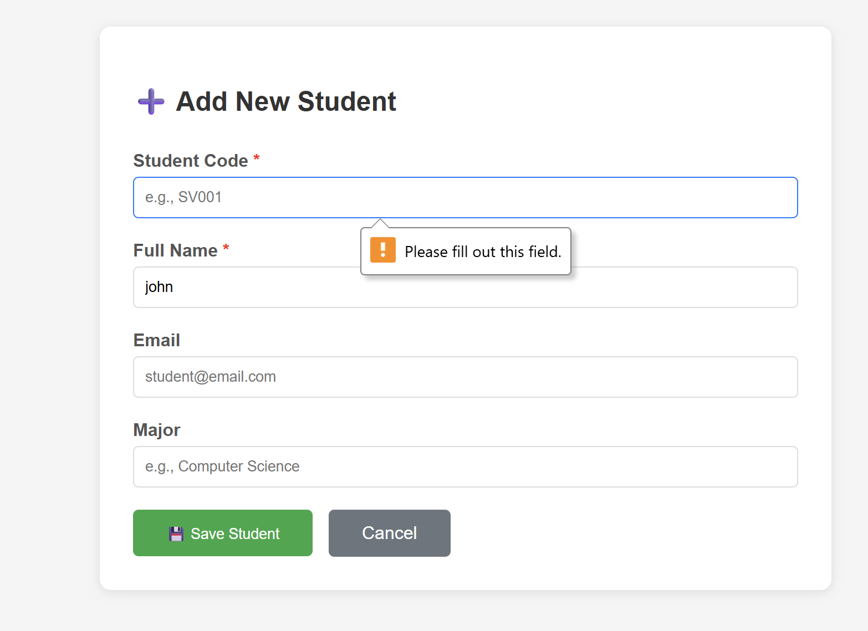
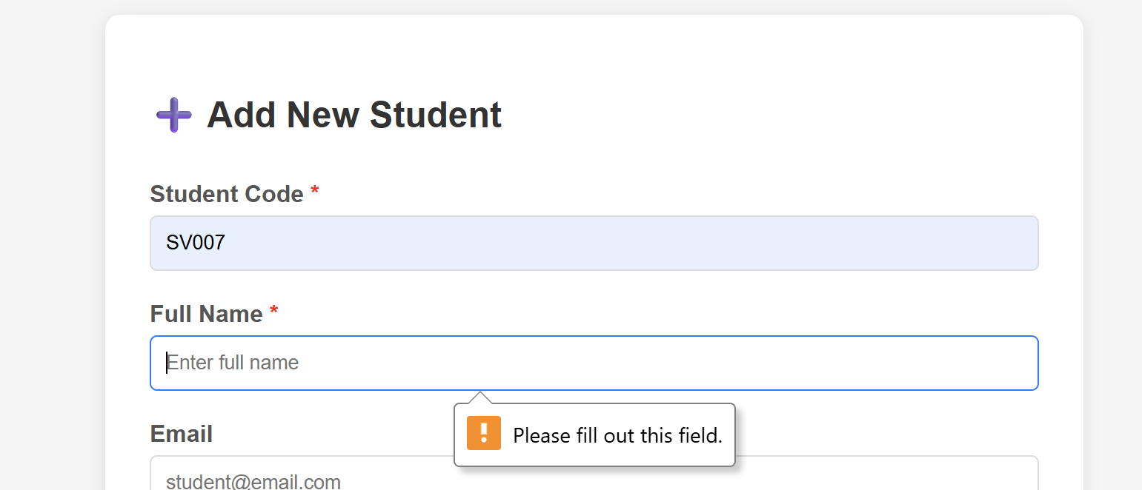

EXERCISE 3: UPDATE OPERATION (15 points)
Estimated Time: 35 minutes
Task 3.1: Create Edit Form (7 points)
Create edit_student.jsp that displays a pre-filled form.
Requirements:
- Get student ID from URL parameter (?id=1)
String idParam = request.getParameter("id");
- Query database for student with that ID
String sql = "SELECT * FROM students WHERE id = ?";
pstmt = conn.prepareStatement(sql);
pstmt.setInt(1, studentId);
rs = pstmt.executeQuery();
- Display form with pre-filled values
- Student code field should be readonly
- Handle case where student ID doesn't exist
- Include hidden input for student ID
Task 3.2: Process Update (8 points)
Create process_edit.jsp to handle update.
Requirements:
- Retrieve student ID and form data
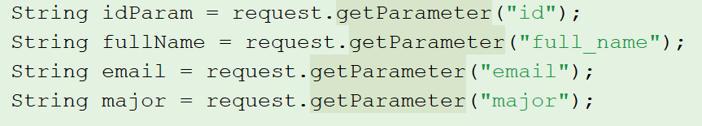
- Validate inputs
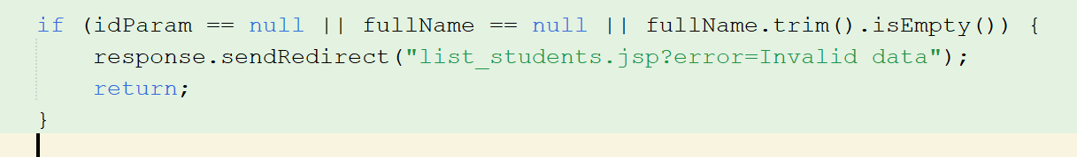
- Update database using PreparedStatement
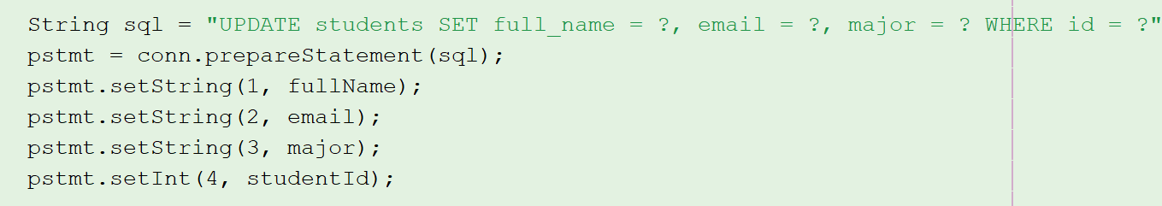
- Redirect to list on success
- Display error on failure

Test :
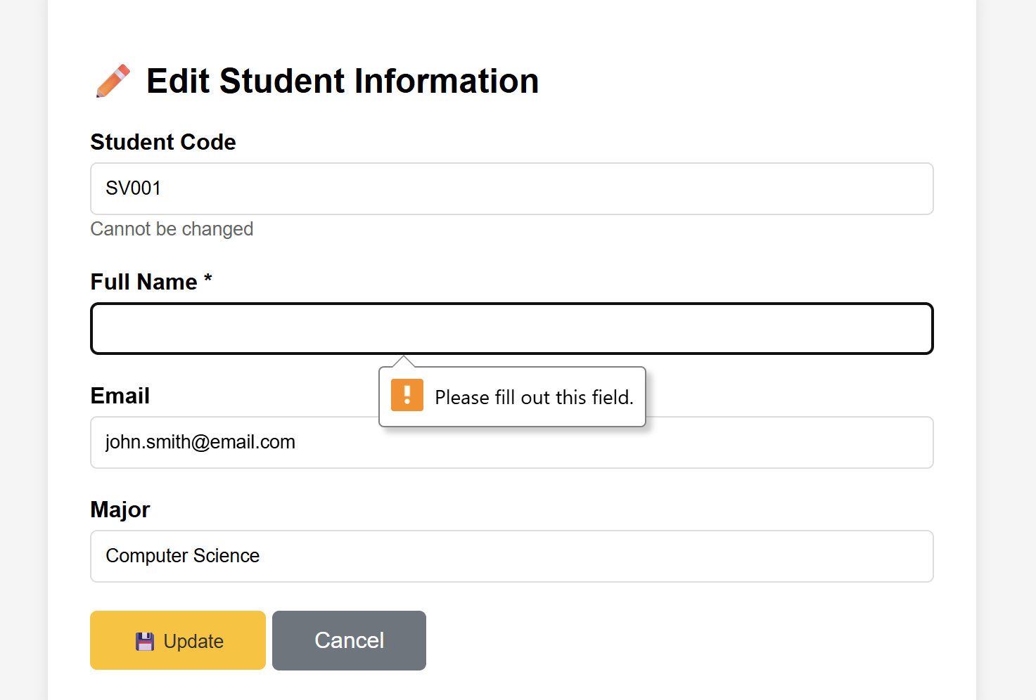

EXERCISE 4: DELETE OPERATION (15 points)
Estimated Time: 25 minutes
Task 4.1: Implement Delete (10 points)
Create delete_student.jsp to delete a student.
Requirements:
- Get student ID from URL parameter
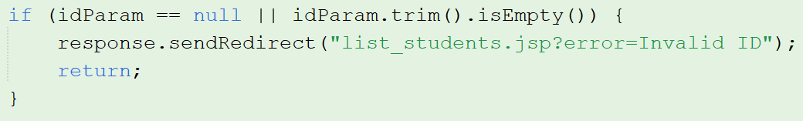
- Delete record from database
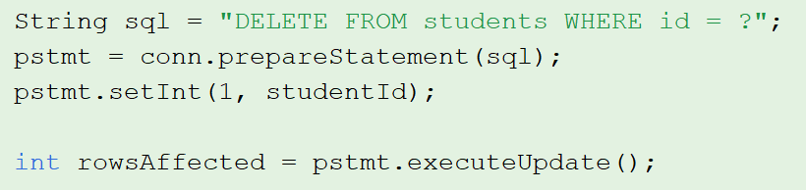

- Redirect to list with message
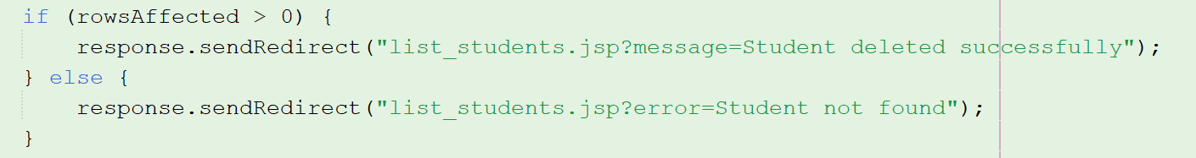
- Handle errors (ID not found, database errors)
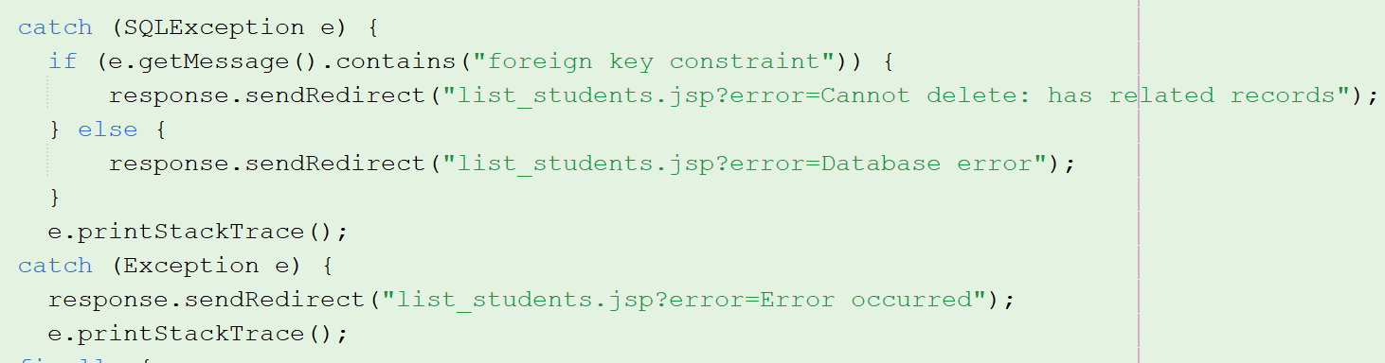

Task 4.2: Add Delete Links and Confirmation (5 points)
Modify list_students.jsp to add delete functionality.
Requirements:
- Add "Delete" link for each student in table
- Link format: delete_student.jsp?id=[student_id]
- Add JavaScript confirmation dialog
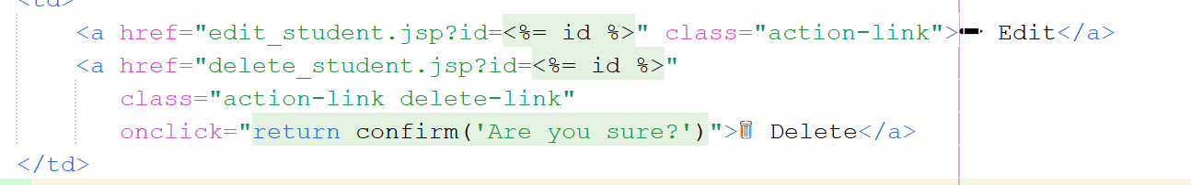
- Style delete link in red color
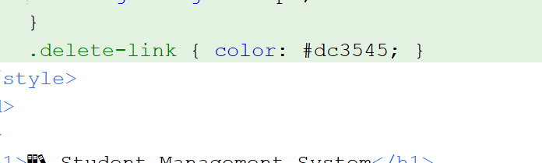

Test
